Problem Statement 2:

Modify the previous program to list all the files and sub-directories in the HDFS path recursively.

Code:

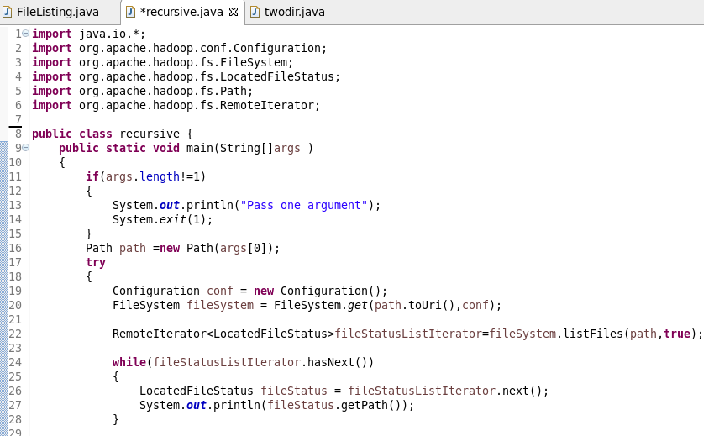

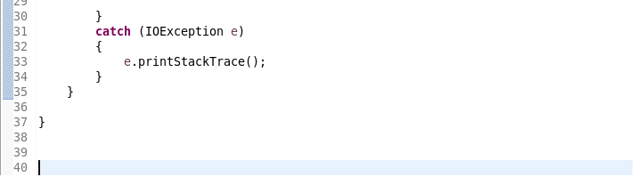

Output:

